A PROJECT SYNOPSIS REPORT ON
“Deepfake Detection System using Deep Learning+LSTM”

Submitted to
SAVITRIBAI PHULE PUNE UNIVERSITY

In Partial Fulfilment of the Requirement for the Award of MASTER’S OF COMPUTER APPLICATION
SECOND YEAR MCA
BY
KHADIJA ASIF GHARTKAR B-221
VINAYAK KHOSE PATIL B-232
PRATHAMESH VIJAY MANDLIK B-234

UNDER THE GUIDANCE OF

Prof Bisweswar Thakur

DEPARTMENT OF COMPUTER ENGINEERING TRINITY ACADEMY OF ENGINEERING KONDHWA, PUNE - 411048

2025-2026

AFFILIATED TO

SAVITRIBAI PHULE PUNE UNIVERSITY

ABSTRACT

The rapid spread of Deepfake videos poses significant challenges to the credibility of digital media, raising concerns over privacy, misinformation, and trustworthiness. This research introduces a hybrid model combining Long Short-Term Memory (LSTM) networks and Convolutional Neural Networks (CNNs) to enhance Deepfake detection. By leveraging ResNeXt-50 for extracting relevant features and LSTMs for capturing frame-to-frame dependencies, the proposed architecture effectively detects altered facial features in videos.
Key pre-processing techniques, including face detection, extraction, and segmentation, optimize input data by isolating relevant facial regions. Experimental results demonstrate that this approach outperforms current methods in identifying subtle Deepfake artifacts, underscoring the need for robust detection mechanisms to protect the credibility of digital media. Future work will explore improved scalability and real-time applications of this technique.
Contents
- Motivation 1
- Literature Survey 2
- Problem Formulation 3
- Project Planning 4
- Facilities required for proposed work: 5
- References 6

List of Figures
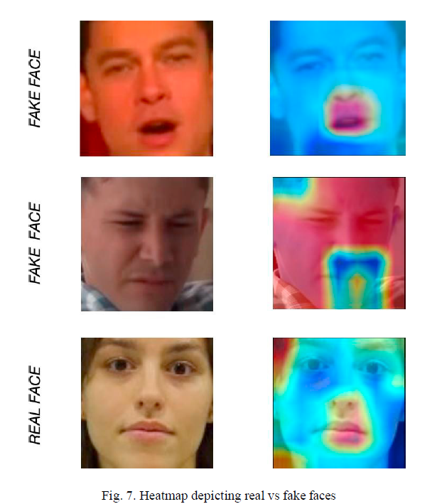
Fig No.1:-

Fig No.2:-
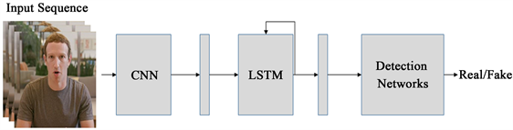

Fig No.3:-
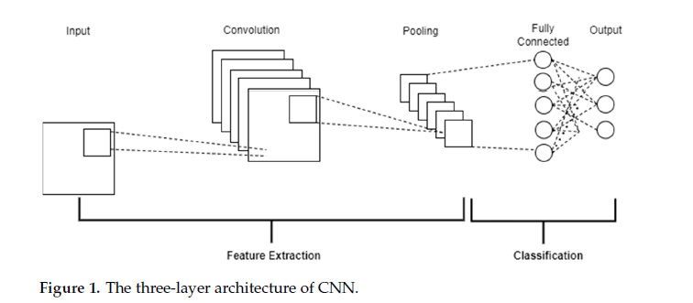

MOTIVATION
Motivation for Hybrid CNN–LSTM Deepfake Detection
1. Eroding Trust
Deepfakes impersonate public figures and media sources, spreading convincing false statements that undermine confidence in digital content.
2. Personal Harm
Non-consensual intimate imagery, identity theft, and blackmail powered by deepfakes inflict irreversible reputational damage.
3. Social Disruption
Viral deepfakes fuel disinformation, amplify divisions, and can trigger real-world unrest through manipulated video content.
4. Financial Fraud
“CEO voice” scams and fake market announcements enabled by audio and video deepfakes have already cost companies hundreds of thousands of dollars.
5. Detection Gaps
· Spatial-only or temporal-only methods miss key pixel-level or motion inconsistencies.
· Overfitting to known generators fails against novel deepfake techniques.
· Resource-heavy models cannot run in real time on streaming platforms or mobile devices.

Proposed Solution
A hybrid CNN–LSTM model with transfer learning that fuses frame-level artifact detection (CNN) and sequence analysis (LSTM), achieving >98% precision with minimal false positives—scalable for real-time, edge-device deployment.
Impact
Our hybrid approach empowers media organizations, governments, and individuals with a robust, real-time defense against deepfakes—preserving trust in digital content and safeguarding societies from the growing threat of synthetic misinformation.

Literature Survey
In the recent times there is an explosive growth in the number of deepfakes. In the present times there are many softwares that facilitate the creation of these deepfakes. They are becoming a threat to privacy, democracy and trust. So, there is an increase in the demand for deepfake analysis. We are listing some of the approaches for deepfake detection.

1. Jadhav et.al, have developed a web based platform with which a user can easily classify it as real or fake by uploading the video. The model used ResNeXt and LSTM. The method is user friendly and reliable. The approach was based on feature extraction from frame level features using ResNext and sequential processing using LSTM. The methodology included dividing the videos into frames and then cropping the frames across face. Some of the selected frames were combined to form face in video thereby they created a new dataset containing face cropped of all videos.Then they have calculated quite good accuracy using confusion matrix which is used for modelevaluation.
2. Y. Li, S. Lyu, have proposed a new method of comparison between generated face areas and their surrounding regions using Conventional Neural Networks. The method was based on observation whether images of limited resources can be generated by the DF algorithm.
3. U. A. Ciftci, I. Demir and L. Yin, have aimed on feature extraction and then computing coherence and temporal consistence. The method extracted biological signals from facial regions from the fake and real video pair. An SVN and a CNN have been trained to find probabilities of authenticity.
4. D. Guera and J. Delp, have used recognition pipeline to automatically detect deepfakes. They have proposed a two step analysis. During first stage, features are extracted at frame level using CNN. The second stage consists of RNN which will capture erratic frames introduced due to face swapping process. The dataset contains 600 videos collected from various online sources was analysed. The accuracy achieved by their model is 94 percent.
5. Y. Li, MC. Chang and S. Lyu, have intoduced a new system of exposing deepfakes based on the eyeblinking which are generated using neural networks. The paper focused on analysing the eyeblinking in the video as it is a natural signal and it cannot be presented well in the synthesized media. In the method the videos have been first preprocessed to locate face area in each frame, hen a Long Term Recurrent Convolution Network(LRCN) find out temporal incongruity.

Problem Formulation

Objective

To design and implement a deep learning-based system for real-time deepfake detection in images and videos, leveraging hybrid Convolutional Neural Networks (CNN) and Long Short-Term Memory (LSTM) networks. The goal is to accurately distinguish between authentic and manipulated facial content across large-scale, real-world datasets.

Scope
- Multi-modal Input: Support for both static images and video streams (frame-by-frame processing).
- Automated Feature Extraction: Use CNNs to automatically learn and extract spatial features (artifacts, texture mismatches) from faces.
- Temporal Pattern Analysis: Apply LSTMs to capture inter-frame inconsistencies and unnatural motion patterns unique to deepfakes.
- Scalable Pipeline: System should handle large datasets (e.g., DFDC, FaceForensics++) and support near real-time inference.
- Adaptability: Architecture supports fine-tuning for new manipulation techniques and data.
- User Interface: Web-based dashboard for uploading content, visualizing detection results, and reviewing flagged segments.

Methodology
- Data Acquisition: Curate and collect publicly available labeled datasets (FaceForensics++, Celeb-DF, DFDC, etc.), ensuring diversity in manipulation methods and quality levels.
- Preprocessing: Extract frames from videos. Use automated face detection (OpenCV, face_recognition) for cropping, resizing, and normalization of facial regions to standard input size.
- Model Development:
- CNN Backbone: Deploy pretrained CNNs (ResNext, ResNet, or InceptionResNetV2) to generate robust feature embeddings for each frame.
- LSTM Module: Stack LSTM or Bi-LSTM layers to analyze frame sequences, leveraging memory for pattern recognition over time.
- Classification Head: Use fully connected layers and a sigmoid/softmax output to classify input as real or fake.

Fig No.4:-
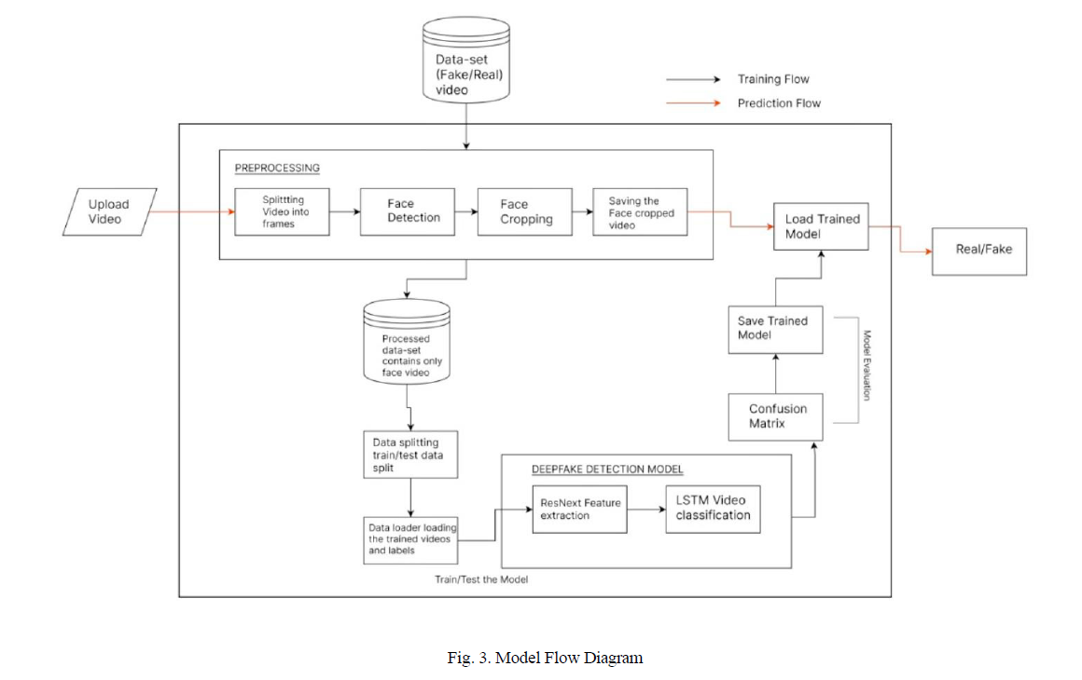
- Training and Evaluation: Employ transfer learning for faster convergence. Optimize hyperparameters (batch size, learning rate, sequence length) and monitor metrics such as accuracy, precision, recall, F1-score, and ROC-AUC. Utilize cross-dataset validation for robustness.
- Deployment: Package model in an efficient form for deployment as a web/API service. Integrate with user interface for interactive detection with visual explanations (e.g., saliency maps, sequence attention).
- Continuous Learning: Allow for periodic retraining or updating as new types of deepfake attacks emerge, improving system resilience.

Novelty of the Work
- Hybrid CNN–LSTM Design for Spatio-Temporal Analysis:
This approach leverages a combination of Convolutional Neural Networks (CNNs) for extracting intricate spatial features from each video frame and Long Short-Term Memory (LSTM) networks for modeling temporal inconsistencies across frame sequences. Such synergy enables more accurate detection of deepfake artifacts that might evade single-modality models.

- Straightforward and Automated Preprocessing:
The system uses automated face detection and cropping to focus only on relevant facial regions from images and videos. It also resizes and organizes these face images to ensure consistent input for the model. These steps make the training process more effective and help the model perform reliably on a wide range of deepfakes, even those with different qualities and formats.

- Cross-Benchmark Validation with Transfer Learning:
Building upon validated strategies in the literature, transfer learning is integrated to adapt pre-trained CNN backbones (e.g., ResNeXt) for deepfake detection tasks, significantly reducing the required training data and accelerating model convergence. The framework further demonstrates effectiveness across major public datasets (FaceForensics++, Celeb-DF, DFDC), ensuring robust generalization to unseen manipulation techniques and realistic scenarios

Project Planning

Project Planning Steps
- Requirement Analysis & Dataset Collection
- Select/curate datasets (e.g., DFDC, FaceForensics++) ensuring balance (real/fake content).
- Data Preprocessing
- Frame extraction, face detection/cropping (OpenCV, face_recognition), normalization.
- Feature Engineering
- Extract spatial features using deep CNNs (e.g., ResNeXt, ResNet, InceptionResNetV2).
- Model Development
- Integrate CNN backbone for spatial analysis.
- Stack LSTM (or bidirectional LSTM) for temporal sequence learning.
- Add fully connected layers for binary classification (real vs. fake).
- Training & Validation
- Utilize transfer learning for better convergence.
- Optimize hyperparameters (learning rate, batch size, epochs).
- Monitor using loss, accuracy, and validation metrics.
- Testing & Evaluation
- Confusion matrix, accuracy, F1-score, ROC-AUC.
- Cross-dataset validation for robustness.
- Deployment & User Interface
- Package as a web-based tool or API for practical usage.
- Optimize for real-time inference.
- Documentation & Reporting
- Prepare final report, code comments, and user manual.

Milestones: Literature review ➔ Data pipeline ready ➔ Model prototype ➔ Validation/Evaluation ➔ Deployment ➔ Final documentation.

Facilities required for proposed work:

Category | Item | Purpose / Objective
Hardware | High-performance GPU-enabled workstation/cloud (NVIDIA GPU, 16GB+ RAM) | To ensure efficient training, inference, and handling of complex deep learning models in a reasonable timeframe, enabling near real-time detection.
 | Sufficient storage for large video datasets (200GB+ recommended) | To store extensive datasets (videos and images) used for training, validation, and testing, ensuring ample data availability for robust model development.
Software/Frameworks | Programming: Python 3.x | Provides a versatile, widely-supported language for developing deep learning models, data processing, and automation scripts.
 | Deep Learning: TensorFlow/Keras or PyTorch | Enables implementation and training of CNN-LSTM models with high flexibility, efficiency, and GPU acceleration support.
 | Computer Vision: OpenCV, dlib/face_recognition | Facilitates face detection, alignment, and preprocessing necessary for extracting relevant regions from videos for analysis.
 | Data Handling: Pandas, Numpy | Supports efficient data manipulation, organization, and numerical computations crucial for dataset processing and feature engineering.
 | Visualization: Matplotlib, Seaborn | Assists in visualizing training metrics, model performance, and dataset characteristics for analysis and debugging.
Additional | Internet access for literature and datasets | Necessary for downloading datasets, pre-trained models, research papers, and updates, ensuring the latest developments are incorporated.
 | GPU cloud access (Google Colab, Kaggle, AWS) | Offers scalable, on-demand computational resources for training large models, especially when local hardware is insufficient.
 | Backup solutions (cloud storage, RAID) | Ensures data security and recovery in case of hardware failure, maintaining workflow continuity.
 | Security measures (encryption, access control) | Protects sensitive data, models, and research artifacts against unauthorized access or breaches.

References
- Sagara, N.K.; Arukonda, S. A Novel CNN–LSTM Approach for Robust Deepfake Detection. Procedia Computer Science 258 (2025) 1844–1855. https://doi.org/10.1016/j.procs.2025.04.436
- Tipper, S.; Atlam, H.F.; Lallie, H.S. An Investigation into the Utilisation of CNN with LSTM for Video Deepfake Detection. Appl. Sci. 2024, 14, 9754. https://doi.org/10.3390/app14219754
- Maurya, R.; Jaiswal, R.; Kumari, P.; Rajpoot, A.; Verma, K. Deepfake Detection System Using ResNet, LSTM and CapsuleNet. Int. Res. J. Modernization Eng. Technol. Sci. 06/Issue 12, December-2024. https://www.irjmets.com/docs/December2024/3852.pdf
- Yadav, P.; Jaswal, I.; Maravi, J.; Choudhary, V.; Khanna, G. DeepFake Detection Using InceptionResNetV2 and LSTM. Proc. Emerging Technologies: AI, IoT, CPS, NITTTR Chandigarh, 06–07 Sep 2021. https://doi.org/10.1109/ICEAICPS52561.2021.9623699
- Pathan, M.; Malshikare, H.; Khairnar, S.; Kharkar, A.; Joshi, S.; Suryawanshi, D. Deepfake Detection Using Deep Learning: ResNext and LSTM. ICCUBEA, PCCOE Pune, 23–24 Aug 2024. https://doi.org/10.1109/ICCUBEA61740.2024.10775025
- Al-Dulaimi, O.A.H.H.; Kurnaz, S. A Hybrid CNN-LSTM Approach for Precision Deepfake Image Detection Based on Transfer Learning. Electronics 2024, 13, 1662. https://doi.org/10.3390/electronics13091662
- Kornhunov, P.; Marcel, S. Deepfakes: A New Threat to Face Recognition? Assessment and Detection. IEEE FG Workshops 2018. https://doi.org/10.1109/FGW.2018.00037
- Rossler, A.; Cozzolino, D.; Verdoliva, L.; Riess, C.; Thies, J.; Nießner, M. FaceForensics++: Learning to Detect Manipulated Facial Images. ICCV 2019. https://doi.org/10.1109/ICCV.2019.00009
- Afchar, D.; Nozick, V.; Yamagishi, J.; Echizen, I. Mesonet: A Compact Facial Video Forgery Detection Network. IEEE WIFS 2018. https://doi.org/10.1109/WIFS.2018.8630761
- Li, Y.; Chang, M.-C.; Lyu, S. In Ictu Oculi: Exposing AI-Created Fake Videos by Detecting Eye Blinking. IEEE WIFS 2018. https://doi.org/10.1109/WIFS.2018.8630787
- Ciftci, U.A.; Demir, I.; Yin, L. FakeCatcher: Detection of Synthetic Portrait Videos Using Biological Signals. IEEE TPAMI 2020. https://doi.org/10.1109/TPAMI.2020.3009287
- Güera, D.; Delp, E.J. Deepfake Video Detection Using Recurrent Neural Networks. IEEE AVSS 2018. https://doi.org/10.1109/AVSS.2018.8639163
- Sabir, E.; Cheng, J.; Jaiswal, A.; AbdAlmageed, W.; Masi, I.; Natarajan, P. Recurrent Convolutional Strategies for Face Manipulation Detection in Videos. CVPR Workshops 2019. https://doi.org/10.1109/CVPRW.2019.00067
- Dang, H.; Liu, F.; Stehouwer, J.; Liu, X.; Jain, A.K. On the Detection of Digital Face Manipulation. CVPR 2020. https://doi.org/10.1109/CVPR42600.2020.00582
- Karras, T.; Laine, S.; Aila, T. A Style-Based Generator Architecture for Generative Adversarial Networks. CVPR 2019. https://doi.org/10.1109/CVPR.2019.00453

